Mobile Gaming Applications in Tourism – A Case Study Using Tamsui Cuisine

S.C. Chien ^{a,}*, C. H. Hsieh^{b}, H. W. Wu^{b}, C.T. Wang^{b}
ªAletheia University, 32, Chen-Li, Tamsui, New Taipei, Taiwan
E-mail address: au4268@mail.au.edu.tw

^{b} Aletheia University, 32, Chen-Li, Tamsui, New Taipei, Taiwan
E-mail address: hwnahee3003@hotmail.com

ABSTRACT
This study examined the innovative approach of combining the cuisine and tourist attractions of Tamsui, Taipei, using mobile devices equipped with a tourism gaming application (app). In this study, the Xcode development environment of iOS mobile application development software was used to conduct game planning and design. Using the characteristics of mobile devices, game interactivity, and the practices and history of the cuisine of Tamsui, Taipei, the new application supports tourism objectives by providing users with sightseeing information in a manner that enhances the readability, interest, and educational value of this information. In this study, four game levels, which represent behavior associated with Tamsui cuisine, were successfully developed. Each level is associated with one of the following dishes, which are Tamsui’s most representative specialties: fish crisps, iron eggs, fish ball soup, and A-gei. In the game, historical stories are interspersed among food production simulations to convey interesting and educational tourist guide information to users. In addition, the game interface provides map locations for Tamsui’s attractions and food vendors, which provides users the functionality of a tourist map.

Keywords: tourism, application, mobile devices

- INTRODUCTION

In recent years, there has been rapid growth in markets related to the tourism industry. Among the basic needs associated with tourism activities, which include "food, clothing, housing, transportation, education, and entertainment," food represents the easiest and fastest way to convey an understanding of local culture. For instance, one representative event that used a food-based approach was the "2013 Taiwan Food Activities Series" organized by the Taiwan Tourism Bureau. Moreover, the Guardian [1] reported that food specialties have enabled Taiwan to quickly gain international attention. The country has been ranked as one of the world’s top 40 tourist destinations, which suggests the indispensable role of cuisine in tourism. Additionally, the objectives of tourism activities are focused on local guidance. With this guidance, local cultural characteristics may be explored. In this way, the ultimate goals of tourism are accomplished.
The use of technology in the tourism industry has become a trend that will determine the industry’s future. Most modern navigation applications (apps) provide information through texts and illustrative pictures. Although thorough data can be conveyed by these apps, there is a lack of interactivity and accessibility. However, the interactive nature of gaming can be used to increase the acceptance of information.
The concept known as interaction design refers to "designing interactive products to support people in their everyday and working lives" [2]. Wang [3] observed that the fundamental spirit of interaction design involves considering what each user wants to do at the different moments and steps of a process. Winograd [4] described interaction design as "designing spaces for human communication and interaction."
Kristo and Satran [5] claimed that good interaction design should involve an interface with the following features: orientation, navigation, usability, functionality, and integration. Neilson [6] proposed that interface usability, which encompasses many facets and components, could be classified in terms of five characteristics: learnability, efficiency, memorability, a low error rate, and user satisfaction. In addition, other scholars believe that to help users more readily appreciate the functional options and contents of the virtual world, interaction design should use metaphors and image maps that are easy to understand and use [7].
Currently, the use of app-based mobile communication technology is expanding rapidly in the tourism industry. However, few apps use a perspective that combines mobile gaming and tourism. In this study, the modern technological development trend of mobile gaming is combined with the guidance function of the tourism industry. Specifically, the Xcode development environment of iOS mobile application development software was employed to construct a navigation-based game app that used the cuisine of Tamsui, Taipei, as an example that provides information regarding food practices interspersed with history. The game’s interactions convey tourist information to users in a manner that enhances the readability, interest, and educational value of this information.

- RESEARCH METHODS

The following research procedure was employed. First, the research topics were determined, and the background, motivation, and purpose of the research were established. Second, the literature was investigated and collected. Third, a model game framework was determined on which to construct the mobile navigation application presented in this study. A constructivist approach was used that involved planning the game’s framework and methods and then writing the program for the game and developing the game’s graphic design. The research process is depicted in Figure 1.
In planning the structure and approaches of a Tamsui cuisine game, a system of challenges was established. In accordance with the game’s provisions, users must complete a game level’s requirements before the level could be “passed.” This approach requires users to meet psychological challenges. The use of food production processes can satisfy user curiosity regarding food production methods. Moreover, users can reach the goals set forth in the game by controlling the operating interface in any desired manner. In addition, easily understandable images were used to help users comprehend the game's features and options. In this way, the “learnability” and “memorability” characteristics of interface usability could be achieved. This research focused on conveying an understanding of the production practices and history of Tamsui cuisine. An analog map for navigation is incorporated into the developed game, which provided users with a way to understand Tamsui specialties and heritage sites.
Through the planning of the game’s features, we could define a set of game structures through which the history and practices associated with Tamsui food could be presented in an educational manner.
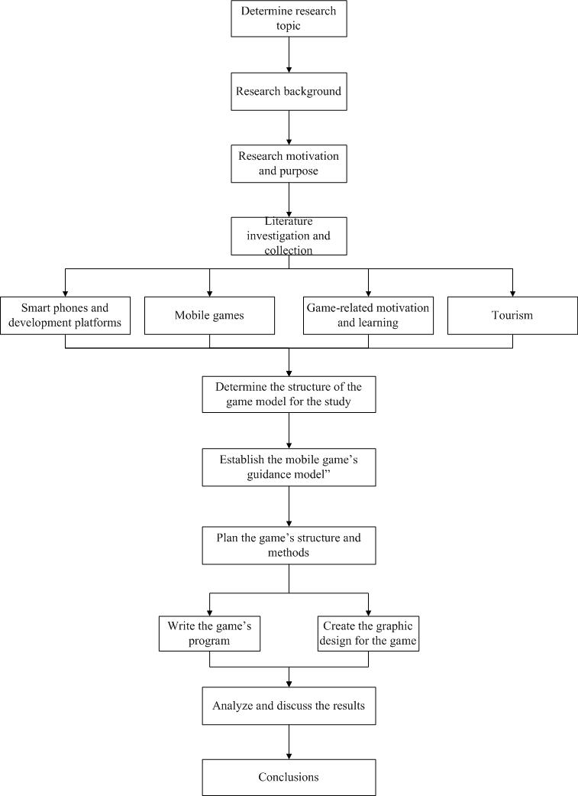
Fig. 1 The planning the game’s framework and methods.

- RESULTS

The app designed in this study was named “Tamsui Kuke.” This name was chosen because it used the Chinese term “ku ke” as a pun on the English word "cook." This app provided a game-based tour of Tamsui food practices. The game’s home page uses a tablecloth, chopsticks, and Tamsui snacks as a background to create a food-themed visual experience. The configuration of buttons on this page includes the "Production Team," "Start Game," and "Settings" buttons, as shown in Figure 2.
The game’s site map ranges from the Tamsui station of the Taipei Rapid Transit System to the end of Tamsui Fisherman's Wharf. As shown in Figure 3, the map contains representative landmarks within this area, such as Oxford College, Fort San Domingo, and the Red Castle.

3.1 The fish crisp level
This section describes each process in the fish crisp level. This level can be entered by tapping the icon for the fish crisp level in the levels screen, as shown in Figures 4. The level preparation screen (Figure 4A) has practices book and history book scroll buttons. Tapping the practices book icon causes users to enter a scrolling screen (Figure 4B) in which they can view information regarding fish crisp practices and game instructions by sliding a finger along the screen. Similarly, tapping the history book icon causes users to enter a history book scrolling screen (Figure 4C) in which they can browse the history of fish crisps by sliding their fingers along the screen. Figure 4D presents the game screen for fish crisp production.
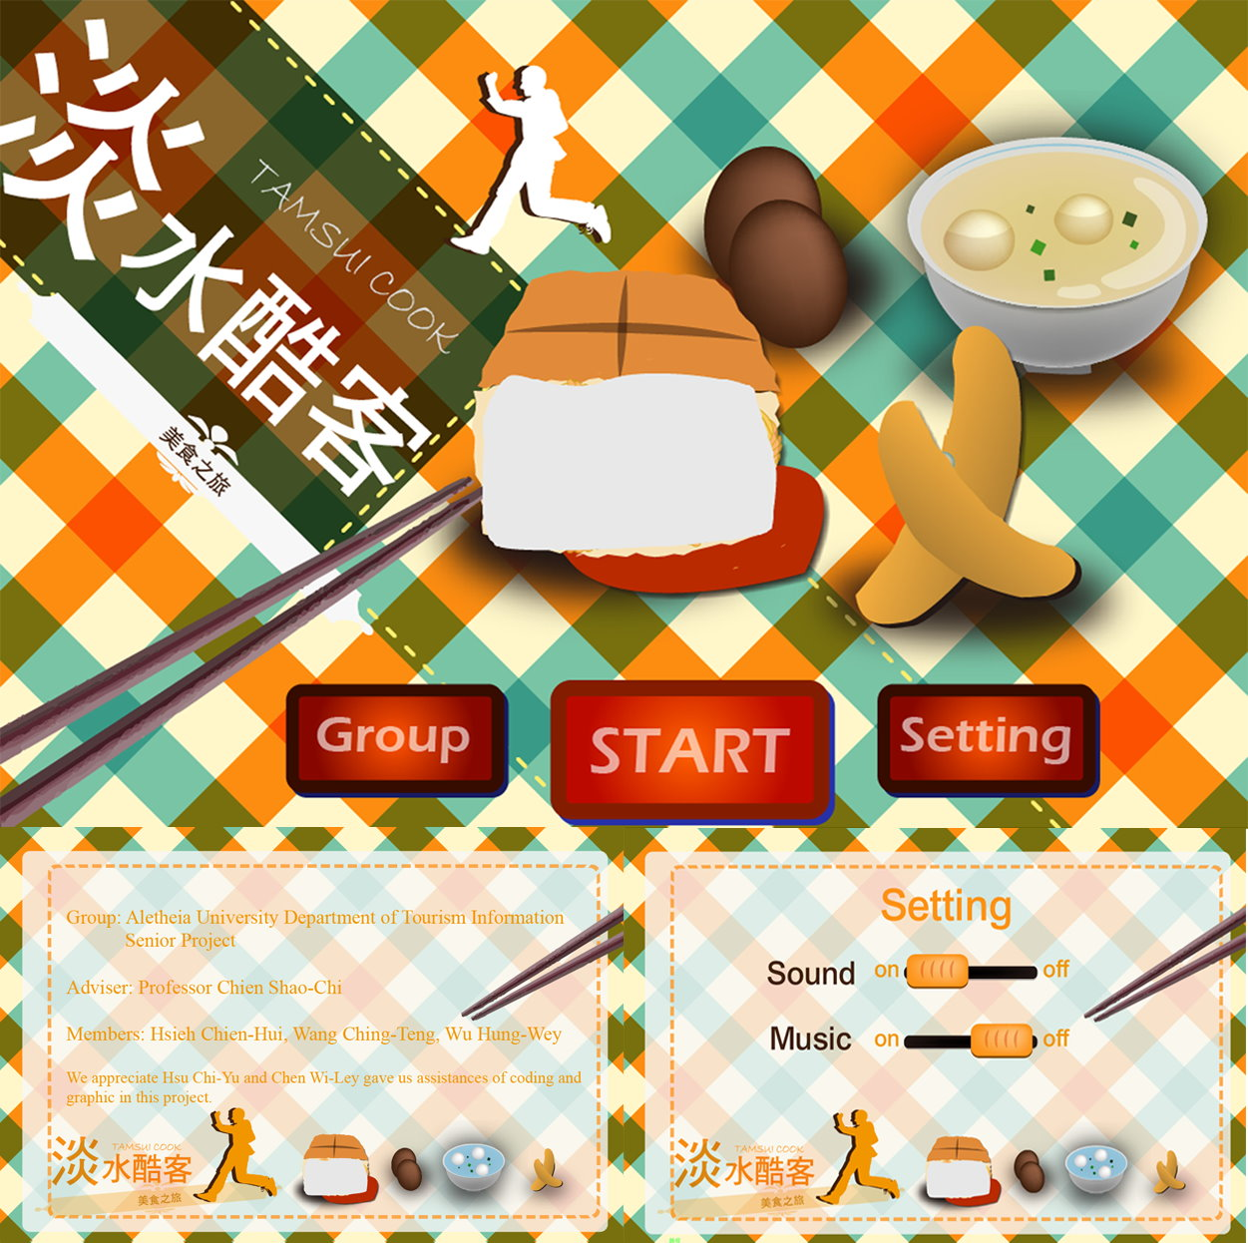
Fig. 2 The configuration of buttons on page includes the "Production Team," "Start Game," and "Settings" buttons.

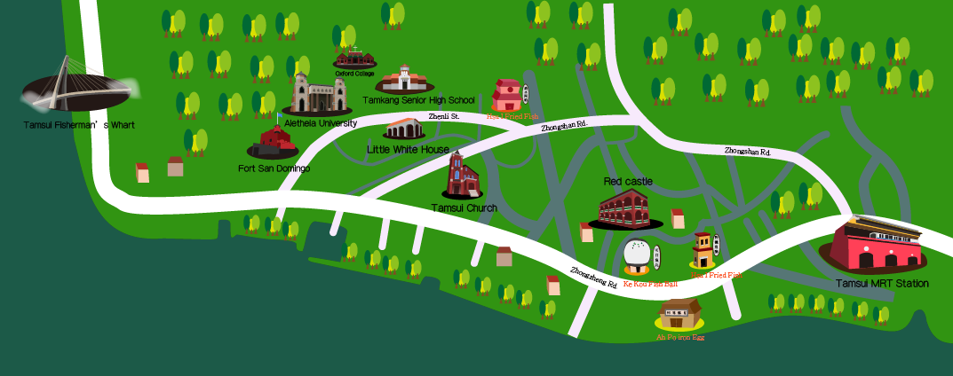
Fig. 3 The game’s site map from the Tamsui station of the Taipei Rapid Transit System to the end of Tamsui Fisherman's Wharf.

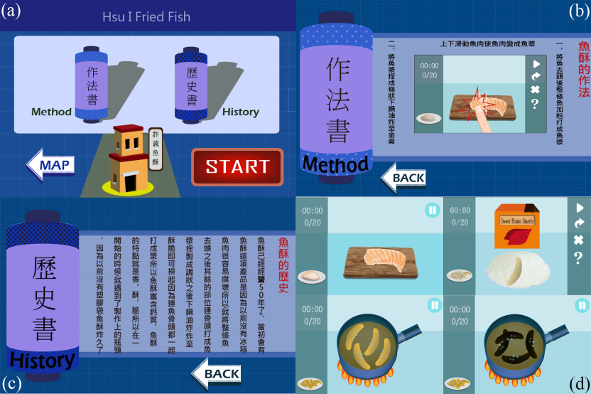
Fig. 4 Tapping the icon and procedures for the fish crisp level in the levels screen.
3.2 The iron egg level
This section shows the procedures in the iron egg level. After entering the pre-game screen (Figure 5a), the practices book and history book scroll buttons appear. Tapping the practices book icon causes users to enter the iron egg practices screen (Figure 5b) in which they can read information regarding iron egg practices and game instructions by sliding their fingers along the screen. Similarly, tapping the history book icon causes users to enter a history book screen (Figure 5c) in which they can browse the history of iron eggs by sliding their fingers along the screen. Figure 5d is the game screen for the stewing process of iron egg production.
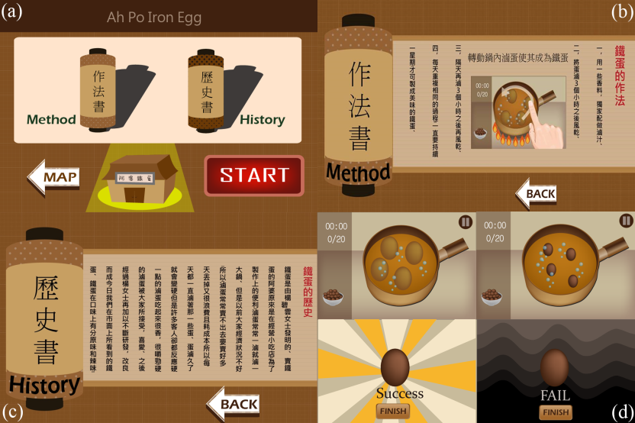
Fig. 5 Tapping the icon and procedures for the iron egg level in the levels screen.

3.3 The fish ball soup level
The screen for the fish ball soup level (Figure 6a) appears when the icon for the fish ball soup level is tapped. After this level has been entered, the game’s screen presents practices book and history book scroll buttons. Tapping the practices book icon causes users to enter a fish ball soup practices screen (Figure 6b) in which they can view information regarding fish ball soup practices and game instructions by sliding their fingers along the screen. Similarly, tapping the history book icon causes users to enter a history book screen for fish ball soup (Figure 6c) in which they can browse the history of fish ball soup by sliding their fingers along the screen. Figure 6d is the game screen for the production of fish ball soup.

3.4 The Ah-gei level
The Ah-gei level screen (Figure 7a) will appear when this level’s icon is tapped. Tapping the practices book icon on this screen causes users to enter an Ah-gei practices screen (Figure 7b) in which they can view information regarding Ah-gei practices and game instructions by sliding their fingers along the screen. Tapping the history book button from the level screen causes users to enter the A-gei history book screen (Figure 7c). Figures 7d and 7e present the game screens for the Ah-gei level.
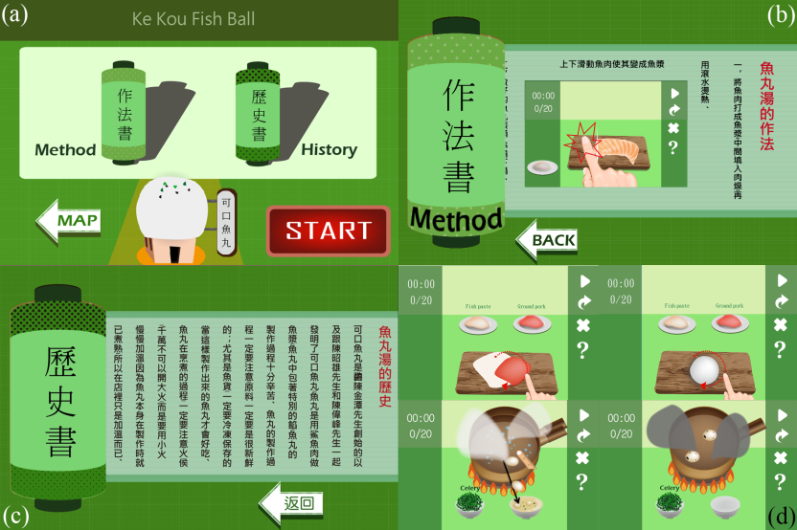
Fig. 6 Tapping the icon and procedures for fish ball soup level in the levels screen.

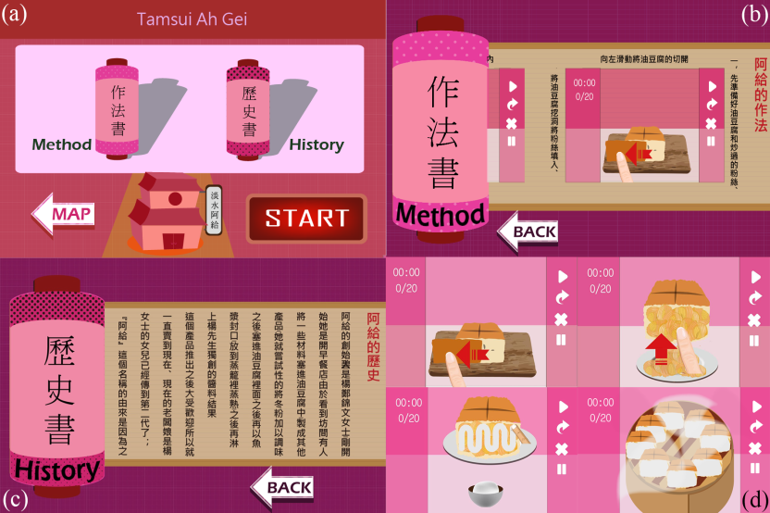
Fig. 7 Tapping the icon and procedures for Ah-gei level in the levels screen.
- RESULTS AND DISCUSSION
The design of each level of the game takes into consideration the research of a number of scholars on the nature of games. Relevant game-related features include gameplay, interest level, touchscreen features, interactivity, creativity, intuitiveness, and variety and diversity. In the following paragraphs, the desirable game-related characteristics achieved by the results of this study are discussed.
- Gameplay and creativity: The original intention of the study design was to use a game as a method of providing guidance regarding the food specialties of Tamsui, Taipei. The game’s design reflects the two dimensions of providing interesting gameplay and conveying educational guidance by innovatively visualizing each step of the traditional production practices of Tamsui cuisine and using easily understandable control methods and interfaces. Thus, the users can achieve the desired result of digital game-based learning.
- The characteristics of interestingness, interactivity, and touchscreen capability: In this study, to introduce interesting features into the game without sacrificing the game’s guidance-providing aspects, time limits and counters were incorporated into certain levels. For example, in the iron egg level, to complete a greater quantity of eggs, users must quickly swipe their fingers across the screen of their mobile device as their allotted time dwindles. This approach provides entertainment value by enabling users to challenge themselves and compete with their friends. In addition, the operating procedures used for each step of each level were designed in accordance with the actual practices used for Tamsui cuisine. For instance, in the stage of the fish crisp level that involves the production of surimi, users quickly click on fish meat displayed on the game screen in a manner that can help them become acquainted with the actual experience of chopping fish meat. The surimi breading stage of the fish crisp level also simulates actual practices. Quickly dragging a finger along the game screen on the in-game image of surimi can cause the surimi to gradually become complete fish crisps.
- Variety and diversity: In the design of each level, the errors and bugs that could be encountered by the program have been considered, resulting in changes to many game details. Using the A-gei level as an example, at the stage of steaming A-gei, the steamer lid can be tapped at different time points to reveal the A-gei, and the program will judge whether different levels of success or failure have been achieved based on the tap timing (i.e., on how thoroughly the A-gei have been cooked).
- Guidance: The game provides images of representative landmarks within the range specified by this study (such as Fort San Domingo, the Red Castle, and the Little White House) and marks them on a map based on the physical locations and relative positions of the landmarks. On the one hand, users can view the broader picture of key Tamsui areas. On the other hand, because of the game’s touchscreen features, users can also more intuitively obtain sightseeing information through the game’s interactive aspects.

- CONCLUSIONS
A comprehensive synthesis of the descriptions provided in each chapter of this study reveals that this investigation began by establishing the background, motivation, and purpose of the research and reviewing relevant literature. Findings from this literature were then used in the practical context of structuring the framework for a game and establishing the game’s rules and methods. Then, the Xcode development environment of an iOS mobile application development platform was used to write the program for the game and demonstrate the research results.
In this study, game levels were successfully developed to simulate the production of four Tamsui dishes: fish crisps, iron eggs, fish ball soup, and A-gei. Moreover, in the game, a map is included to provide guidance by marking the relative positions of Tamsui’s specialty stores and tourist attractions, thereby allowing users to engage in the offline use of their phones for local navigation. Furthermore, this study’s notion of combining tourism and mobile gaming is a topic that has rarely been studied, which suggests this paper’s innovative nature. In this study, understandable images were used to enable users to experience the production practices associated with Tamsui cuisine specialties, challenging game rules were established, and historical stories were interspersed throughout the game. Using this approach, several practices related to Tamsui cuisine were easy to understand. The game created in this study was not only highly educational but also entertaining.

- REFERENCES
[1]The Guardian http://www.theguardian.com/travel/2014/jan/03/holiday-hotspots-where-to-go-in-2014.
[2] Preece, J., Rogers, Y., & Sharp, H. (2002). Interaction design： Beyond human-computer interaction. New York, NY： Wiley
[3] Wang, H. B. (2002), The application of interactive hypermedia design on virtual information space, Master Thesis, Department of Industrial Design, National Cheng Kung University.
[4] Winograd, T. & Wilson, C. (1997). The usability engineering framework for product design and evaluation. In M. G. Helander, T. K. Landauer, and P. V. Prabju (eds.). Handbook of Human-Computer Interaction. Amsterdam, Holland： Elsevier, 653-688.
[5] Kristof, R. & Satran, A. (1995). Interactivity by design： Creating & communicating with new media. Mountain View, CA： Adobe Press, 1995.
[6] Nielsen, J. (1993). Usability Engineering, Academic Press Inc.
[7]Assfalg, J. & Pala, P. (2000). Querying by photographs： A VR Metaphor for Image Retrieval, IEEE Multi-Media, 7(1), January-March, 2000.

